Title of paper here
CORRESPONDING AUTHOR*¹, PRESENTING AUTHOR¹, ANOTHER AUTHOR², and LAST AUTHOR^{1, 3}
¹ Address number one
²Address number two
³Address number three

Type the body of the abstract here. Page and paragraph set-up: please adjust your word processor's setting for A4 paper portrait orientation. Total word count must not exceed 800. Abstracts that run over the prescribed length may be rejected or truncated for publication. Graphics and photos may be included provided that they are in the GIF, TIFF, jpeg or PNG format (Fig. X).
Abcde fghijk lmnop. Qrst uvw xyz. Abcde fghijk lmnop. Qrst uvw xyz. Abcde fghijk lmnop. Qrst uvw xyz. Abcde fghijk lmnop. Qrst uvw xyz. Abcde fghijk lmnop. Qrst uvw xyz. Abcde fghijk lmnop. Qrst uvw xyz. Abcde fghijk lmnop. Qrst uvw xyz.
Abcde fghijk lmnop. Qrst uvw xyz. Abcde fghijk lmnop. Qrst uvw xyz. Abcde fghijk lmnop. Qrst uvw xyz. Abcde fghijk lmnop. Qrst uvw xyz. Abcde fghijk lmnop. Qrst uvw xyz. Abcde fghijk lmnop. Qrst uvw xyz. Abcde fghijk lmnop. Qrst uvw xyz. Abcde fghijk lmnop. Qrst uvw xyz.
Abcde fghijk lmnop. Qrst uvw xyz. Abcde fghijk lmnop. Qrst uvw xyz. Abcde fghijk lmnop. Qrst uvw xyz. Abcde fghijk lmnop. Qrst uvw xyz. Abcde fghijk lmnop. Qrst uvw xyz. Abcde fghijk lmnop. Qrst uvw xyz.

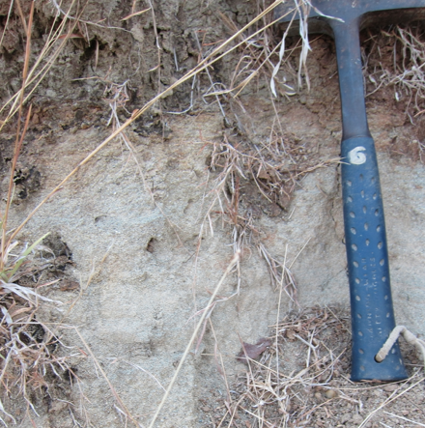
Figure X. Description

*Correspondence may be sent to: abcde@fgh.com

